Alte
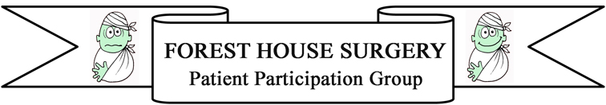
ere

Virtual Patient Group
As a Patient Participation Group (PPG) we need to be representative of the community that Forest House Surgery serves. We need to not only be reflective of the wide age range of patients registered with the Practice but equally of their diversity and health care needs, this can range from parents with young children through to patients with particular health problems for example chronic illnesses. We currently have a full complement of patients serving on the Group who meet regularly to discuss matters affecting the practice and its patients; However, to ensure we are fully representative of the patient community and their needs we would like to build a contingent of ‘virtual’ PPG members who would be happy to be contacted by email on a very occasional basis to complete short questionnaires relating to issues specific to themselves or their Peer group to ensure that the views of as many patient groups as possible are considered.

If you would be happy to do this please complete the form below. The information will purely be used to contact patients to gain their views. The questions will not be medical or personal and your contact details will
be kept safely and securely and will only be used for this purpose and will not be shared with anyone else.

Thank you for your support.

Kind Regards,

Forest House Surgery Patient Participation Group

*Please hand this form to a member of the surgery reception team.

………………………………………………………………………………………………………………………………………………………………………………
I would like to be part of Forest House Surgery Virtual Patient Participation Group

Name:
Email Address:
The following additional information will help us to make sure we try to speak to a representative sample of patients that are registered at the Practice.
Are you? Male Female

Please indicate your age group:
Under 16 |  | 17 - 24
25 - 34 |  | 35 - 44
45 - 54 |  | 55 - 64
65 - 74 |  | 75 - 84
Over 84

