Some Things Must Be Kept Private
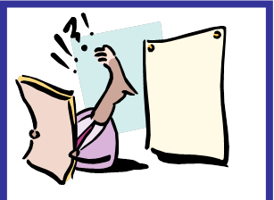

JOE BLOGGS
HAS
DIABETES
AND EVERYONE
KNOWS IT!

The NHS is dedicated to protecting your information

In order to provide you with the best possible healthcare, we need to maintain proper records of your health and make sure that this is available to your medical team, wherever and whenever possible.

All of our staff are trained in their responsibilities to protect your data and are under legal obligations not to disclose this information to unauthorised bodies or people.

Your medical records are vital

We use your records to help us to give you proper healthcare and advice. We also need records to manage and plan the NHS itself in order to provide proper accounting for the public money we spend and to have the right resources in the right place.

We also use medical records in research to help find cures and treatments for illnesses. This helps us and other research bodies better understand diseases and determine which treatments work best under certain circumstances.

When we use this information we make sure that, wherever possible, we do not use personal details such as your name and address, in order to protect your confidentiality.

When releasing information to researchers, we give them only the minimum data necessary, and all their research is carefully vetted

If you have any queries around Data Protection please contact:
Susan Baker (Practice Manager),
Forest House Surgery

01509 508412

